1. **Suppose that a data warehouse consists of the three dimensions date, doctor, and patient, and the two measures count and charge, where charge is the fee that a doctor charges a patient for a visit.**

* Design a star schema for such a data warehouse.
* Identifying the fact table(s) and dimension table(s).
* Identifying their primary key(s), foreign key(s) and measures.

1. **Suppose that a data warehouse for Big-University consists of the following four dimensions: student, course, semester, and instructor, and two measures count and avg. grade. When at the lowest conceptual level (e.g., for a given student, course, semester, and instructor combination), the avg grade measure stores the actual course grade of the student. At higher conceptual levels, avg grade stores the average grade for the given combination.**

* Design a Star Schema for such a data warehouse.
* Identifying the fact table(s) and dimension table(s).
* Identifying their primary key(s), foreign key(s) and measures.

1. **Suppose that a data warehouse consists of the four dimensions, date, spectator, location, and game, and the two measures, count and charge, where charge is the fare that a spectator pays when watching a game on a given date. Spectators may be students, adults, or seniors, with each category having its own charge rate.**

* Design a star schema for such a data warehouse.
* Identifying the fact table(s) and dimension table(s).
* Identifying their primary key(s), foreign key(s) and measures.

1. **Design the data warehouse for a wholesale furniture company.**

**The data warehouse has to allow to analyze the company’s situation at least with respect to the Furniture, Customers and Date. Moreover, the company needs to analyze:**

**the furniture with respect to its type (chair, table, wardrobe, cabinet. . . ), category (kitchen, living room, bedroom, bathroom, office. . . )**

**and material (wood, marble. . . )**

**the customers with respect to their spatial location, by considering at least cities, regions and states**

**The company is interested in learning at least the quantity, income and discount of its sales**

* Design a star schema for such a data warehouse.
* Identifying the fact table(s) and dimension table(s).
* Identifying their primary key(s), foreign key(s) and measures.

1. **Convert 3NF to Dimensional modeling**

* Design a star or snowflake schema for such a data warehouse.
* Identifying the fact table(s) and dimension table(s).
* Identifying their primary key(s), foreign key(s) and measures.

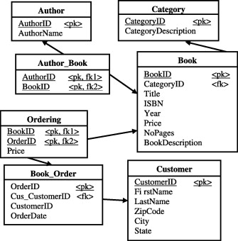

1. **Convert 3NF to Dimensional modeling**

* Design a star or snowflake schema for such a data warehouse.
* 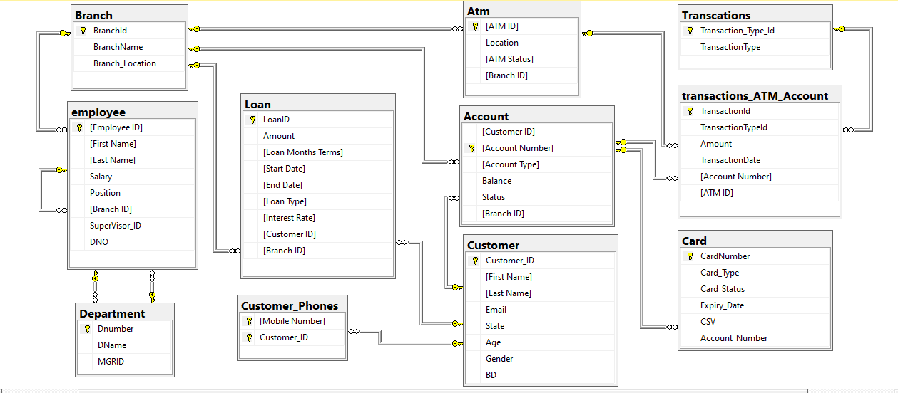Identifying the fact table(s) and dimension table(s).

1. **Convert 3NF to Dimensional modeling**

* Design a star or snowflake schema for such a data warehouse.
* Identifying the fact table(s) and dimension table(s).
* 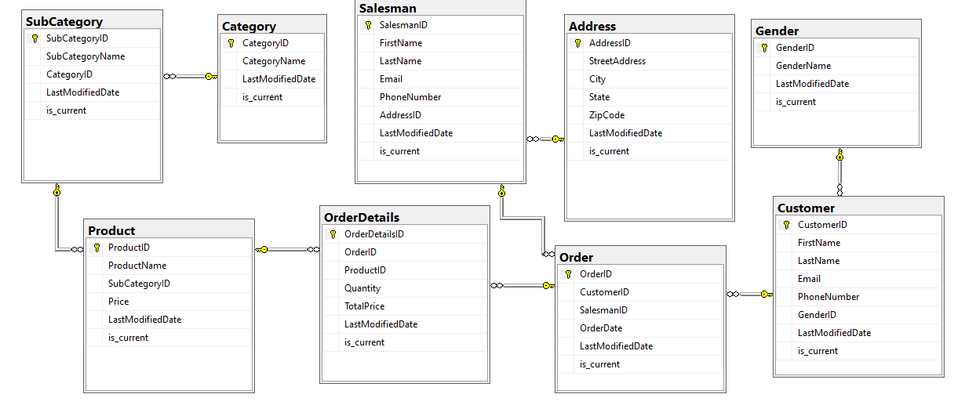Identifying their primary key(s), foreign key(s) and measures.

1. **Convert 3NF to Dimensional modeling**

Gravity Bookstore is a database for a fictional bookstore called that captures information about books, customers, and sales.

* Design a star or snowflake schema for such a data warehouse.
* Identifying the fact table(s) and dimension table(s).
* Identifying their primary key(s), foreign key(s) and measures.

Tables description:

* **book**: a list of all books available in the store.
* **book_author**: stores the authors for each book, which is a many-to-many relationship.
* **author**: a list of all authors.
* **book_language**: a list of possible languages of books.
* **publisher**: a list of publishers for books.
* **customer**: a list of the customers of the Gravity Bookstore.
* **customer_address**: a list of addresses for customers, as a customer can have more than one address, and an address has more than one customer.
* **address_status**: a list of statuses for an address, because addresses can be current or old.
* **address**: a list of addresses in the system.
* **country**: a list of countries that addresses are in.
* **cust_order**: a list of orders placed by customers.
* **order_line**: a list of books that are a part of each order.
* **shipping_method**: the possible shipping methods for an order.
* **order_history**: the history of an order, such as ordered, cancelled, delivered.
* **order_status**: the possible statuses of an order.

